ELEG 312 - Example Problems Chapter 10-2

**Example 10.3**

Find the midband gain *AM* and the upper 3-dB frequency *fH* of a CS amplifier fed with a signal source having an internal resistance *Rsig* = 100 kΩ. The amplifier has *RG* = 4.7 MΩ, *RD* = *RL* = 15 kΩ, *gm* = 1 mA/V, *ro* = 150 kΩ, *Cgs* = 1 pF, and *Cgd* = 0.4 pF. Also, find the frequency of the transmission zero.

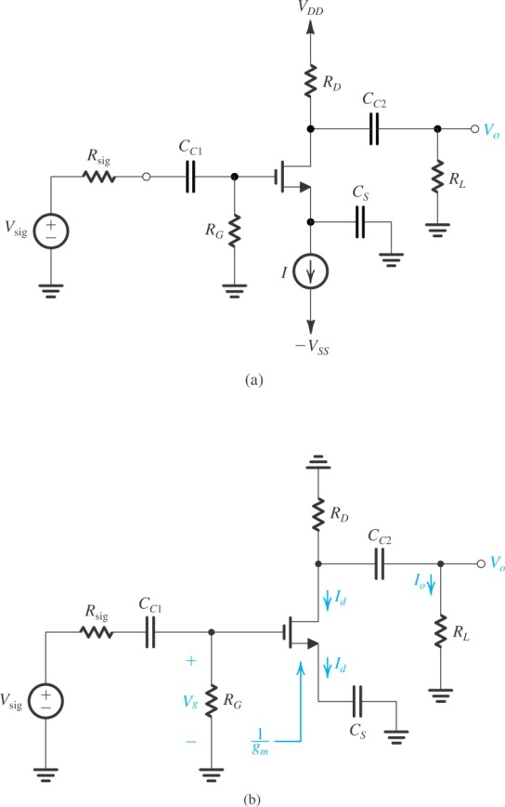

**Example 10.4**

It is required to find the midband gain and the upper 3-dB frequency of the common-emitter amplifier of Fig. 9.4(a) for the following case: *VCC* = *VEE* = 10 V, *I* = 1 mA, *RB* = 100 kΩ, *RC* = 8 kΩ, *Rsig* = 5 kΩ, *RL* = 5 kΩ, *β*0 = 100, *VA* = 100 V, *Cμ* = 1 pF, *fT* = 800 MHz, and *rx* = 50 Ω. Also, find the frequency of the transmission zero.

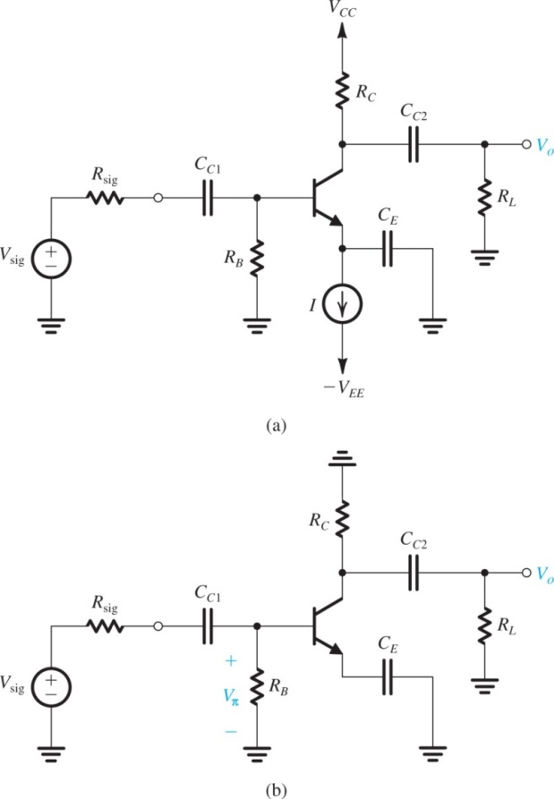

**Example 10.5**

Figure 10.21(a) shows an ideal voltage amplifier having a gain of with an impedance *Z* connected between its output and input terminals. Find the Miller equivalent circuit when *Z* is (a) a 1-M resistance and (b) a 1-pF capacitance. In each case, use the equivalent circuit to determine *Vo/Vsig*.

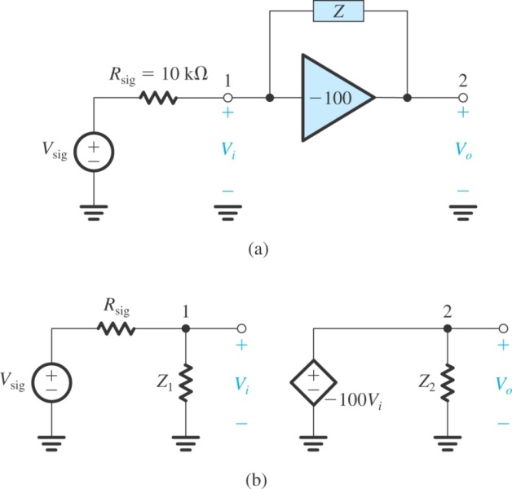

(a) *Z* is a 1-M resistance

(b) *Z* is a 1-pF capacitance

**Example 10.6**

Consider an IC CS amplifier fed with a source having *Rsig* = 0 and having an effective load resistance *R’L* composed of *ro* of the amplifier transistor in parallel with an equal resistance *ro* of the current-source load. Let *gm* = 1.25 mA/V, *ro* = 20 k, *Cgs* = 20 fF, *Cgd* = 5 fF, and *CL* = 25 fF. Find *AM*, *fH*, *ft*, and *fZ*. If the amplifying transistor is to be operated at twice the original overdrive voltage while *W* and *L* remain unchanged, by what factor must the bias current be changed? What are the new values of *AM*, *fH*, *ft*, and *fZ*?